Tiger Mushroom Farms Founder, Te’Lario Watkins II Keynote Speaker for Simon Kenton Boy Scouts of America Luncheon
May 20,2018
Columbus, OH-Ten year old Te’Lario Watkins II, Founder of Tiger Mushroom Farms was the keynote speaker for the Simon Kenton Council Boy Scouts of America Leadership Luncheon. Te’Lario shared his scouting story with over 300 attendees at the Simon Kenton Council Boy Scouts of America Leadership Luncheon. Te’Lario is an active Webelo Cub Scout and he is involved with No Kid Hungry, Food Rescue US and Local Matters to raise money and awareness about hunger and food access for everyone.
The Leadership Luncheon recognizes the community service efforts of leaders in the community.
Priscilla Tyson, Councilmember of the City Of Columbus Council received the Whitney M. Young Jr. Service Award for her dedication to the community. Councilmember Tyson “has worked for job creation, economic development, safety, and a high quality of life for the residents of Columbus”.
Elford Construction received the Community Leadership Award for their values established by their Founder, Edward “Pop” Elford. Elford’s values include being trustworthy, building lasting relationships, building community, working hard and smart and to keep learning.
The Simon Kenton Council awarded Te’Lario with a Camp Scholarship that will be given to a Scout in his honor.
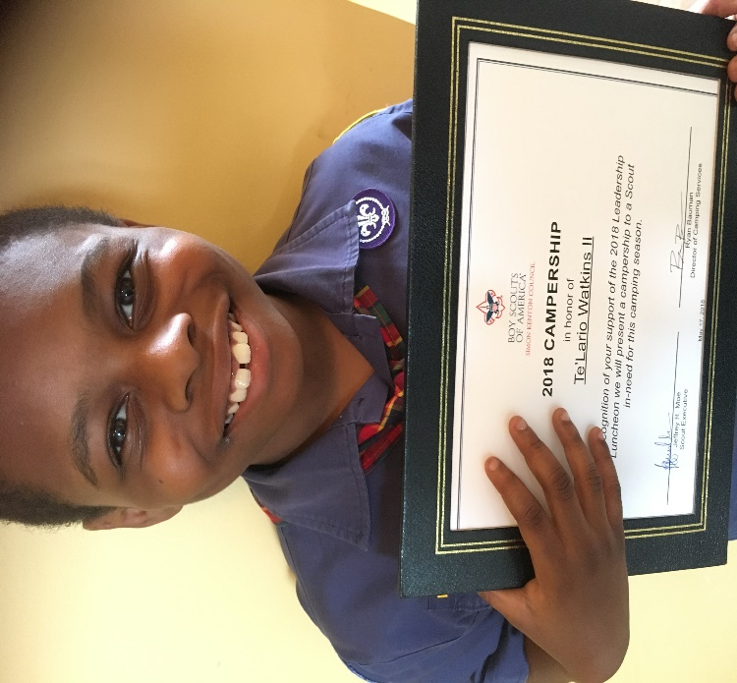
Additional Information:
• Like Tiger Mushroom Farms on Facebook: http://www.facebook.com/tigermushroomfarms/
• Follow Tiger Mushroom Farms on Twitter:
www.twitter.com/MushroomFarms
• Follow Tiger Mushroom Farms on Instagram: www.instagram.com/tigermushroomfarms

About Tiger Mushroom Farms
Tiger Mushroom Farms was founded by Te’Lario Watkins II at the age of 7 after a Cub Scout Project ended. The small family run mushroom farm cultivates shiitake & oyster mushrooms. They have created a shiitake & onion soup mix that can used to season meat and vegetables. It can also be used to create a tasty sour cream dip! Te’Lario is also an author of “Te’Lario’s Amazing Mushroom Farm”, speaker & philanthropist. One of his missions is to end childhood hunger. He is a Hunger Hero with No Kid Hungry.
For more information, visit www.tigermushroomfarms.com.

